**Creating New Users**

**Step1:** Open the database that you want to add a new user too and right click on users and select New User. In this example I created the new user Test1for salesdb.

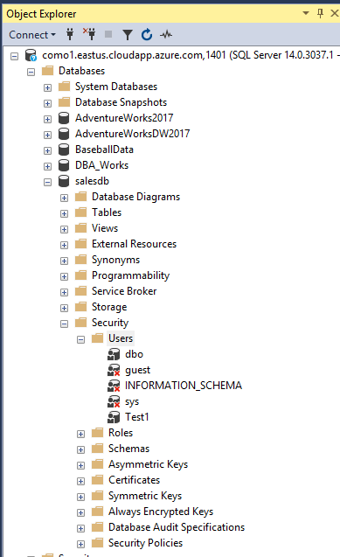

**Step2:** Select the type of user you want it to be a then put the usersname in.

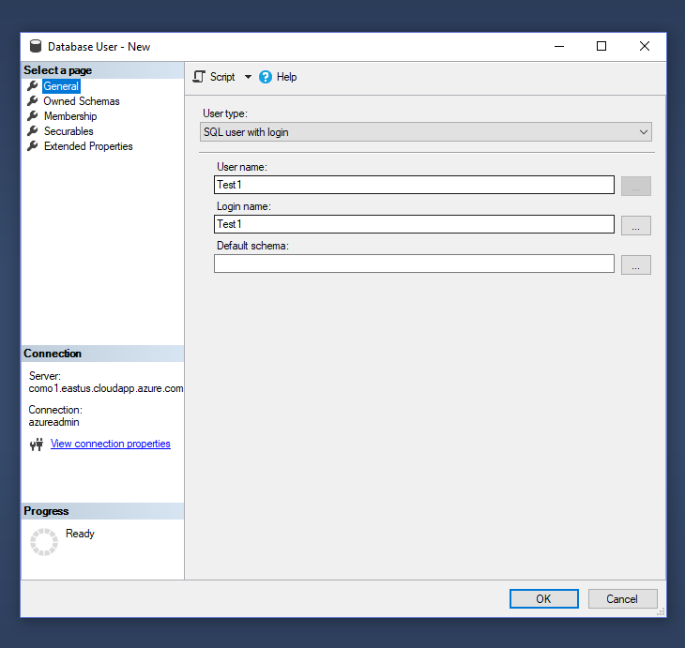

**Step3:** Next you add the new user to the schema groups that they are apart of.

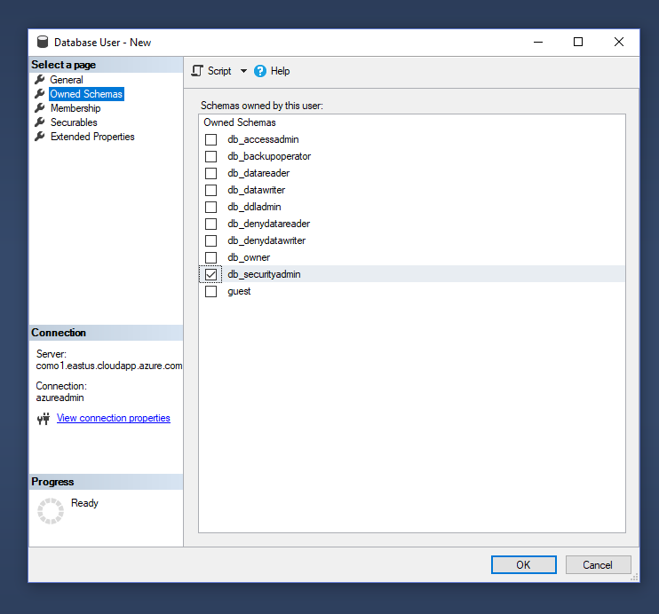

**Step 4:** Assign the new user what groups they will be a member of. This is what permissions they will have with each database.

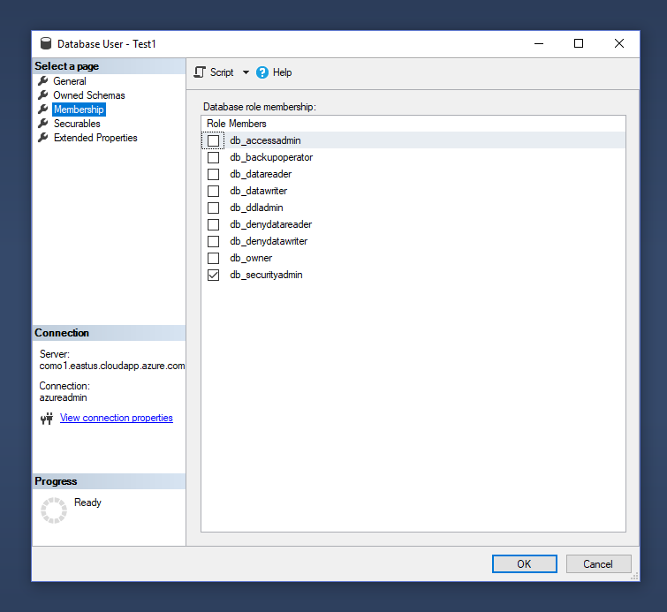

**Step5:** Once you have added the new user into the database and have all them in all of the current memberships and schemas then you will want to move onto making a new login for them.